- Define a class and an object in Visual Basic. Provide a simple example.
- A class is a blueprint or template used to create objects
For example;
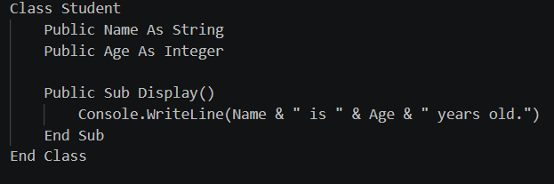
- An object is an instance of a class that represents a real entity created from the class.
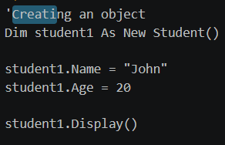
- Differentiate between Inheritance and Polymorphism in OOP.
- Inheritance allow one class to inherit properties and methods from another class while polymorphism allows the same methods to behave differently in different classes
- Inheritance promotes codes reuse while polymorphism proves flexibility in how methods are used.
- Inheritance uses inherits in visual basic while polymorphism can be achieved through overriding.
For example, for Inheritance
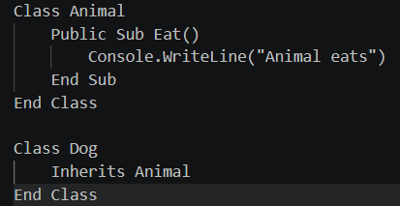

For polymorphism
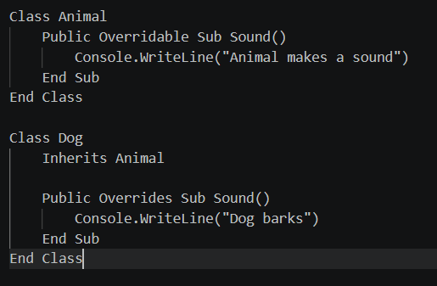
- What is Encapsulation, and why is it important in Object-Oriented Programming?
- Encapsulation means combining data and methods into a single class and restricting direct access to the data. It is important because of the following;

- Protects data from unauthorized access.
- Prevents accidental changes to data.
- Makes programs easier to maintain.
- Improves security and organization

- Describe the purpose of Constructors and Destructors in VB classes.
- A constructor is a special method that runs automatically when an object is created. It is commonly used to initialize the object's data.
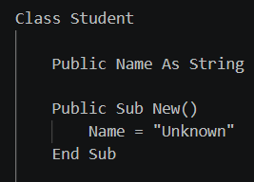
- A destructor is used when an object is being removed from memory.
